**ARDUINO BASED DISINFECTION TUNNEL**

With the rise in covid 19 infections the disinfection tunnel became a necessary equipment for disinfection of people and objects before gaining access to certain areas. This design is one I took part in while serving with the engineering department at NASENI and is made using locally available materials and can be customized to suit a variety of preferences. This repo contains the codes, list of materials and images of the final assembly. However, this repo covers more of the control aspect as it is the more difficult part of the project, and the final assembly can be made using a design and materials of choice to suit your preference.

**OPERATION**

* Push button is pressed and the tunnel is powered up and the buzzer beeps as a power on signal.
* The system checks the level of disinfectant fluid in the tunnel, if it’s above its lowest set point the system runs the pump for half a second and powers it down after that.
* Ultrasonic sensor at the entry senses the presence of an individual at the entry point.
* The buzzer beeps.
* The pumps and valves are activated simultaneously for 500 mS (adjustable). However, if the individual exits the tunnel before the time elapses, the ultrasonic sensor at the exit senses so and powers down the pump and valve.
* The buzzer beeps.
* If an individual goes through the tunnel from the exit point to the entry point, the buzzer beeps and no other action is taken.
* Once the disinfectant fluid goes below its lowest set point, the buzzer beeps continuously and the pumps and permanently off until the tank is refilled.

**COMPONENTS LIST**

1. Arduino uno

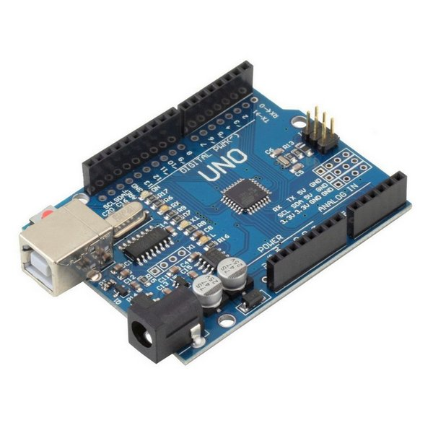

1. Jumper wires

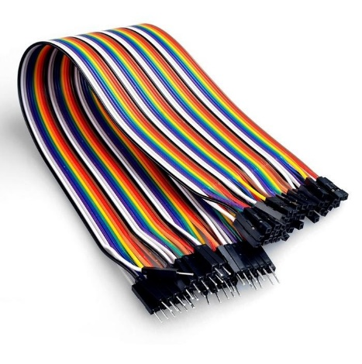

1. Ultrasonic sensors

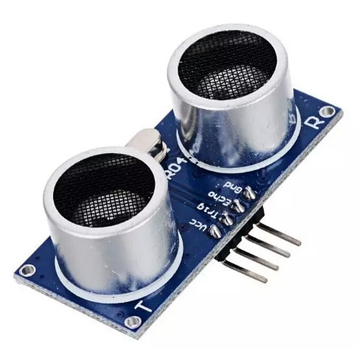

1. Fuel injector (solenoid)

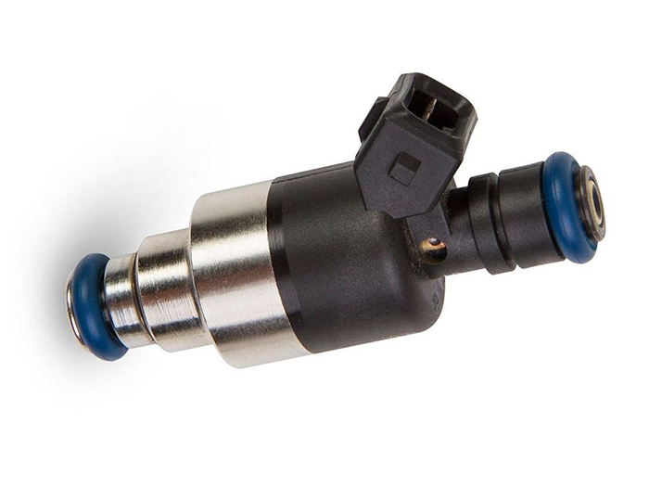

1. Pump (12v car pump)

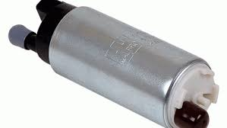

1. Lm2596 buck converter

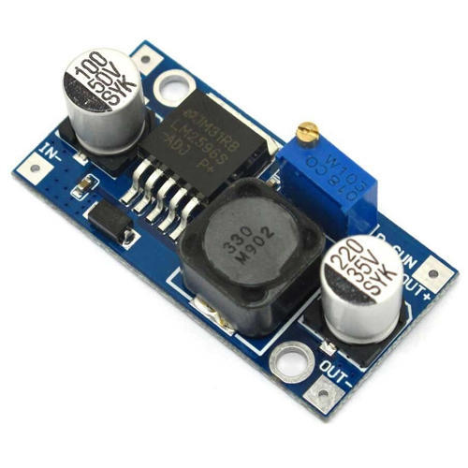

1. Charge controller (12v solar battery charge)

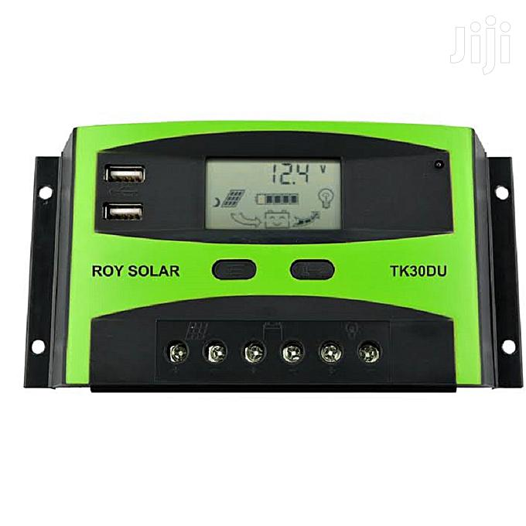

1. Step down transformer (220vAC-12vAC)

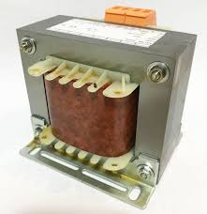

1. Plastic Panel box 200x145x65mm

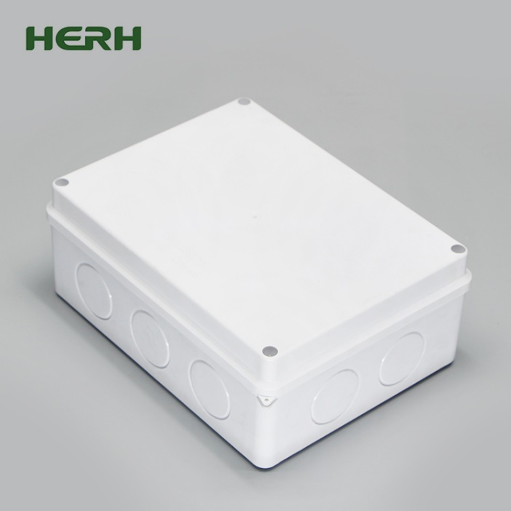

1. Glue gun and sticks

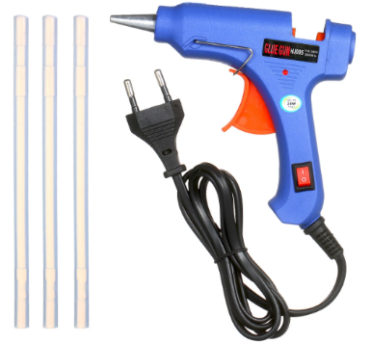

1. Hose

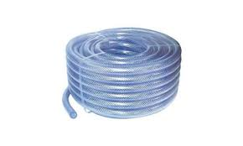

1. Hose clips



1. 5vDc relay

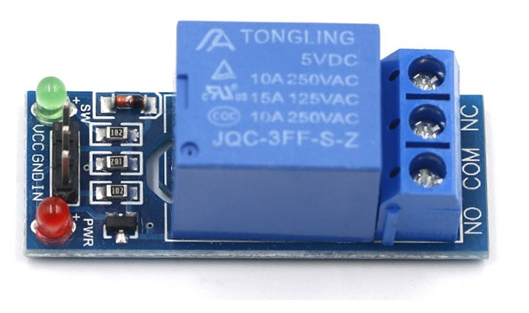

1. 20 liter storage tank

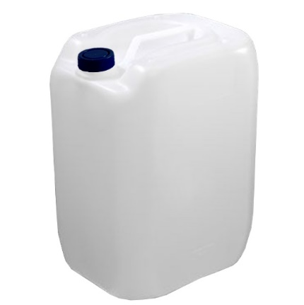

1. Extraction fan 5v DC

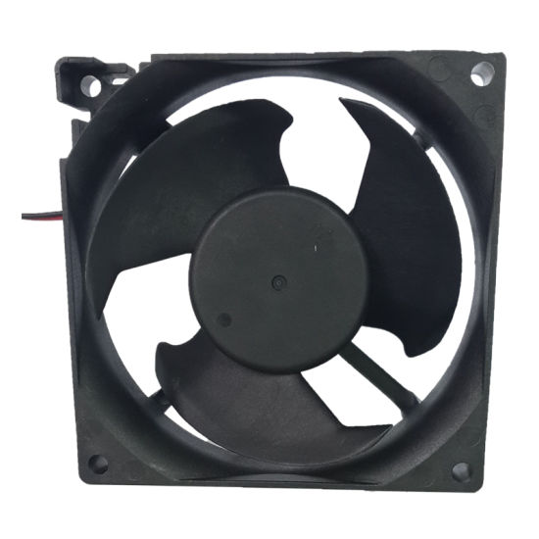

1. Connection terminal

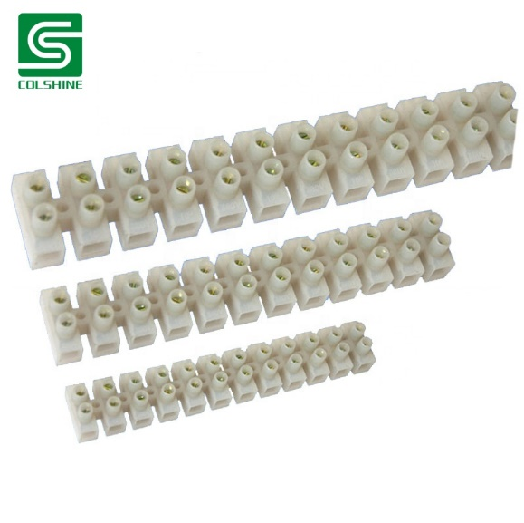

1. Buzzer

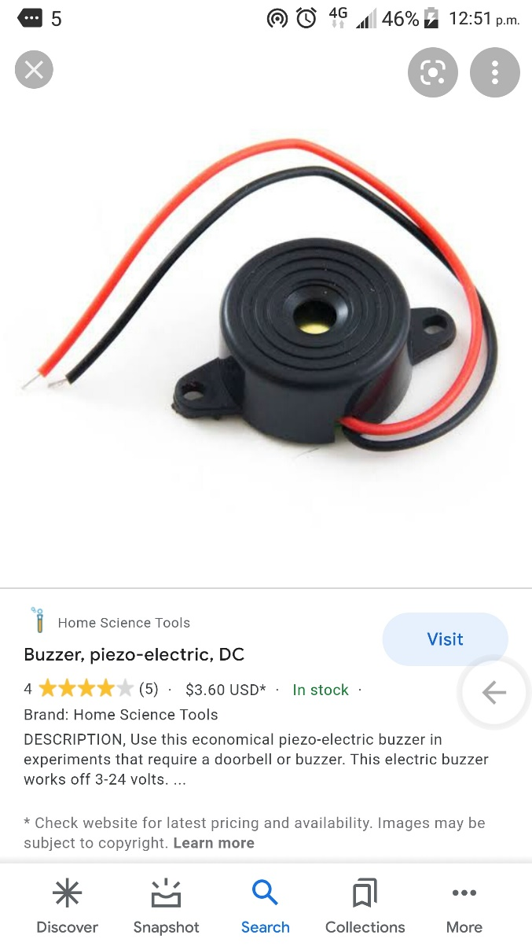

**DISINFECTION TUNNEL CIRCUIT**

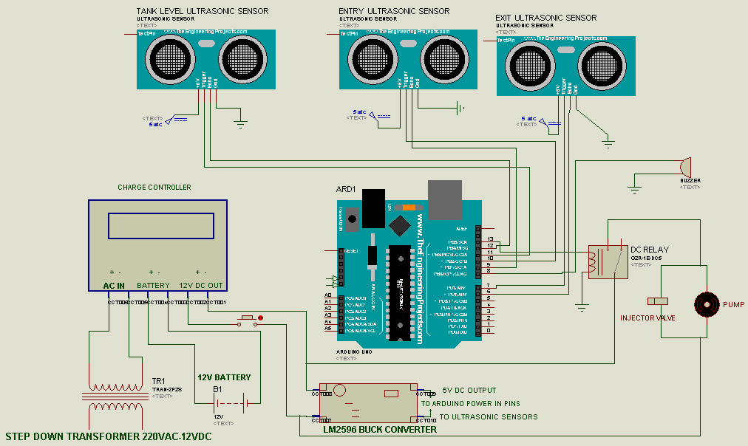Circuit design made with Proteus (proteus file is attached in the disinfection tunnel folder)



**PROCEDURE**

For the body of the tunnel, metal pipes were welded together with some parts joined together with a bolt. The finishing was done using aluminum composite boards (durable material than can easily me modified for placement of sensors and a power button) covering the frame leaving space inside for the storage tank, panel box and wires to run. The body can be made using different materials and a different design hence and we would be focusing mainly on the control aspect in this repo. I have attached a video showing one of the prototype frames I designed using solid works, you can have a look at that to kick start your own design.

1. Plug the arduino board to the PC and upload the code from the ‘disinfection tunnel codes’ folder (the lines from the codes for the tank level can be commented if not required and the tank level ultrasonic sensor disconnected. However, there is a risk of the pump running and burning out when the tank is empty and the tunnel is being used.)
2. Unplug the arduino board from the PC.
3. Cut a hole at the side of the plastic panel box where you plan to place the transformer and attach the fan using the glue gun.
4. Glue the terminal block at the side of the box (outside).
5. Connect the buck converter input to the output of the charge controller and a multimeter to the input while tuning the multimeter on the buck converter until the output is set to 5v DC.
6. Assemble the components as in the circuit diagram above, while placing the arduino board, transformer, buck converter and charge controller in the plastic panel box.
7. The glue gun can be used to glue wires at their points of connections to the components to prevent them from pulling out u se the terminal bock to connect components in the box with sensors, valve, pump, Ac mains and power button.).
8. Cut out holes and place one ultrasonic sensor at the entrance of the tunnel, one at the exit and another in the tank based on the order in the circuit diagram, the sensors can be glues in place.
9. A suitable place should be found to place the push button to power the system.
10. Place the panel box, tank and batter inside the frame or in any special compartment designed for it.
11. Connect the hose to the pump outlet and use hose clips as support to prevent leakage.
12. Place the injector valve at the other end of the hose, cut a hole at the position the valve is to be placed and fasted with cable tie, tape or glue (it’s a good idea to valve the valve at the ceiling of the tunnel).
13. Connect the tunnel to an AC mains supply.
14. Power up the system and test.

Below is what the disinfection chamber looks like on completion.

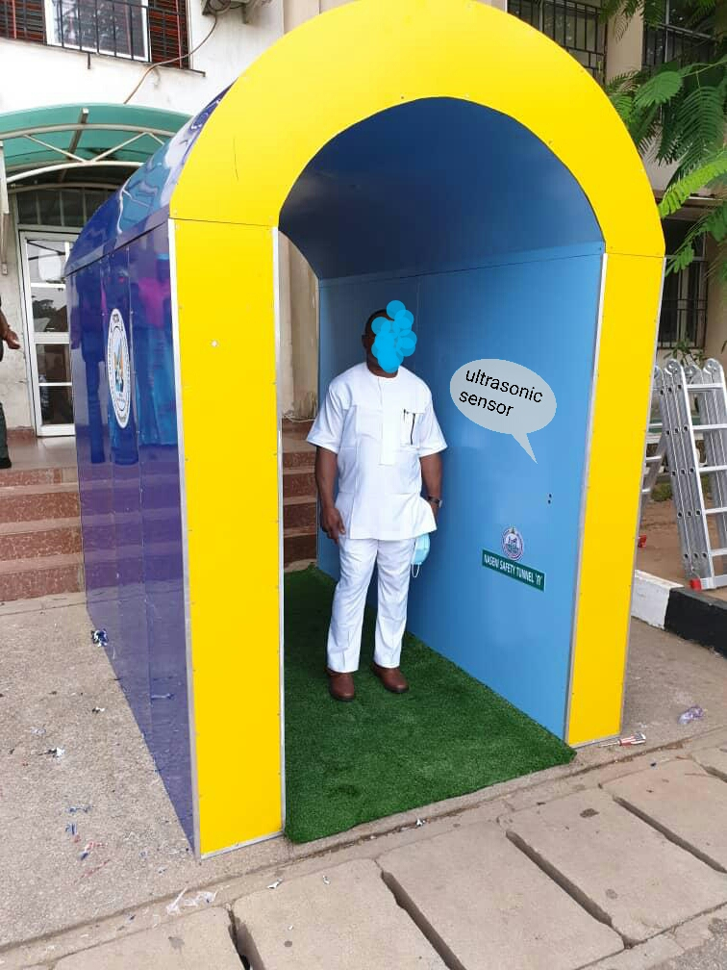

Special thanks for the engineers at the NASENI for the success of the project.

**CONTACTLESS TEMPERATURE SENSOR**

The contactless temperature sensor was made to add the functionality of checking people’s temperature at the entrance of the tunnel without having any contact. Once and individual comes within 6cm to the temperature sensor the persons temperature is taken and displayed on the screen, if the temperature is above 38 degrees (BODY TEMPERATURES above 38 degree is a symptom of covid 190 the buzzer sounds an alarm to warn nearby personnel.

A short video showing its operation is in the contactless temperature folder.

**COMPONENTS**

1. 4 way mini circuit breaker box

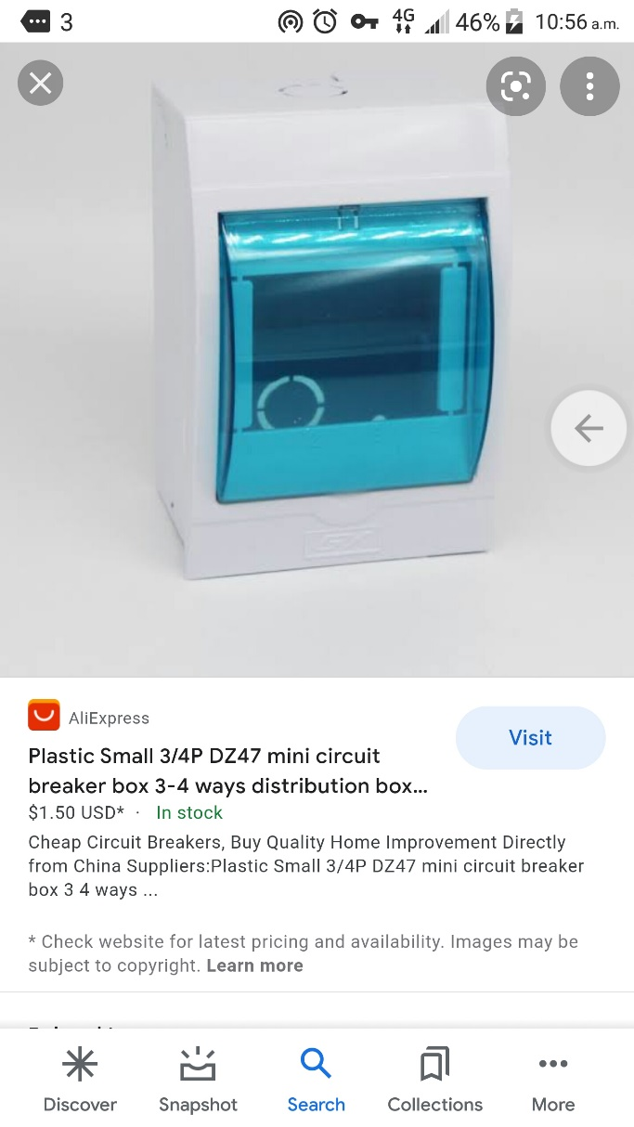

1. MLX90614 contactless temperature sensor

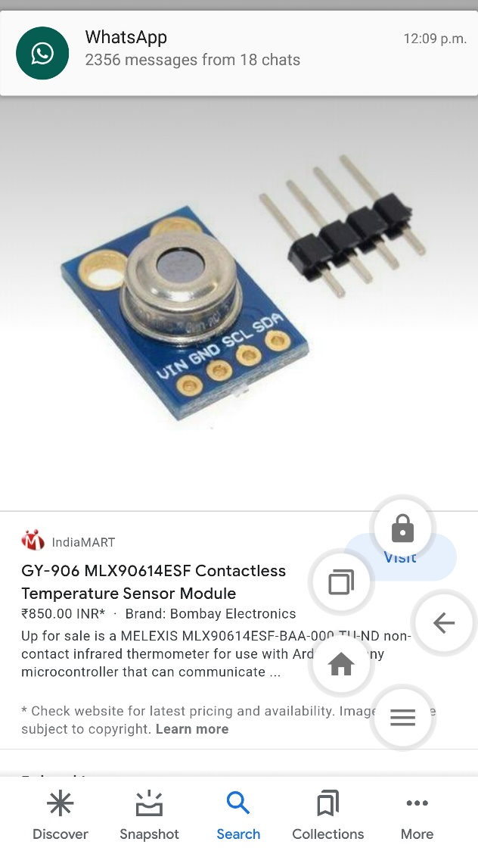

1. Glcd 128x64 display

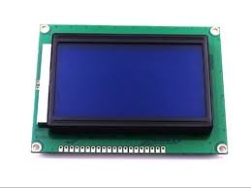

1. Push button switch

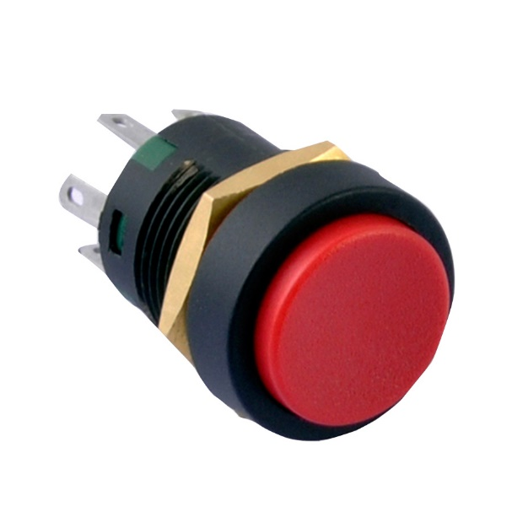

1. 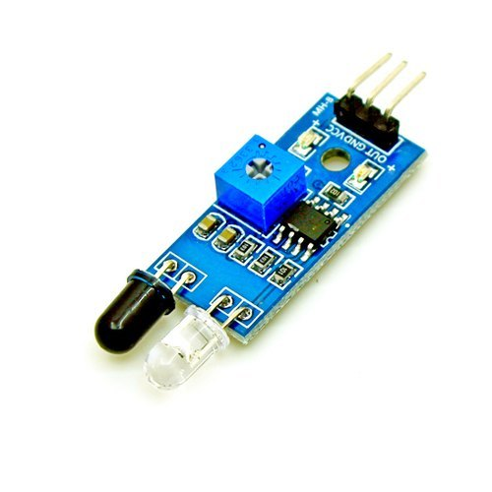Ir proximity sensor

1. Potentiometer

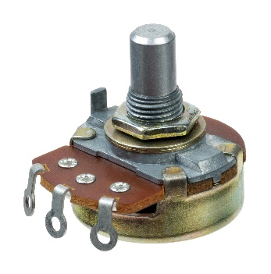

1. Buzzer



CIRCUIT DIAGRAM

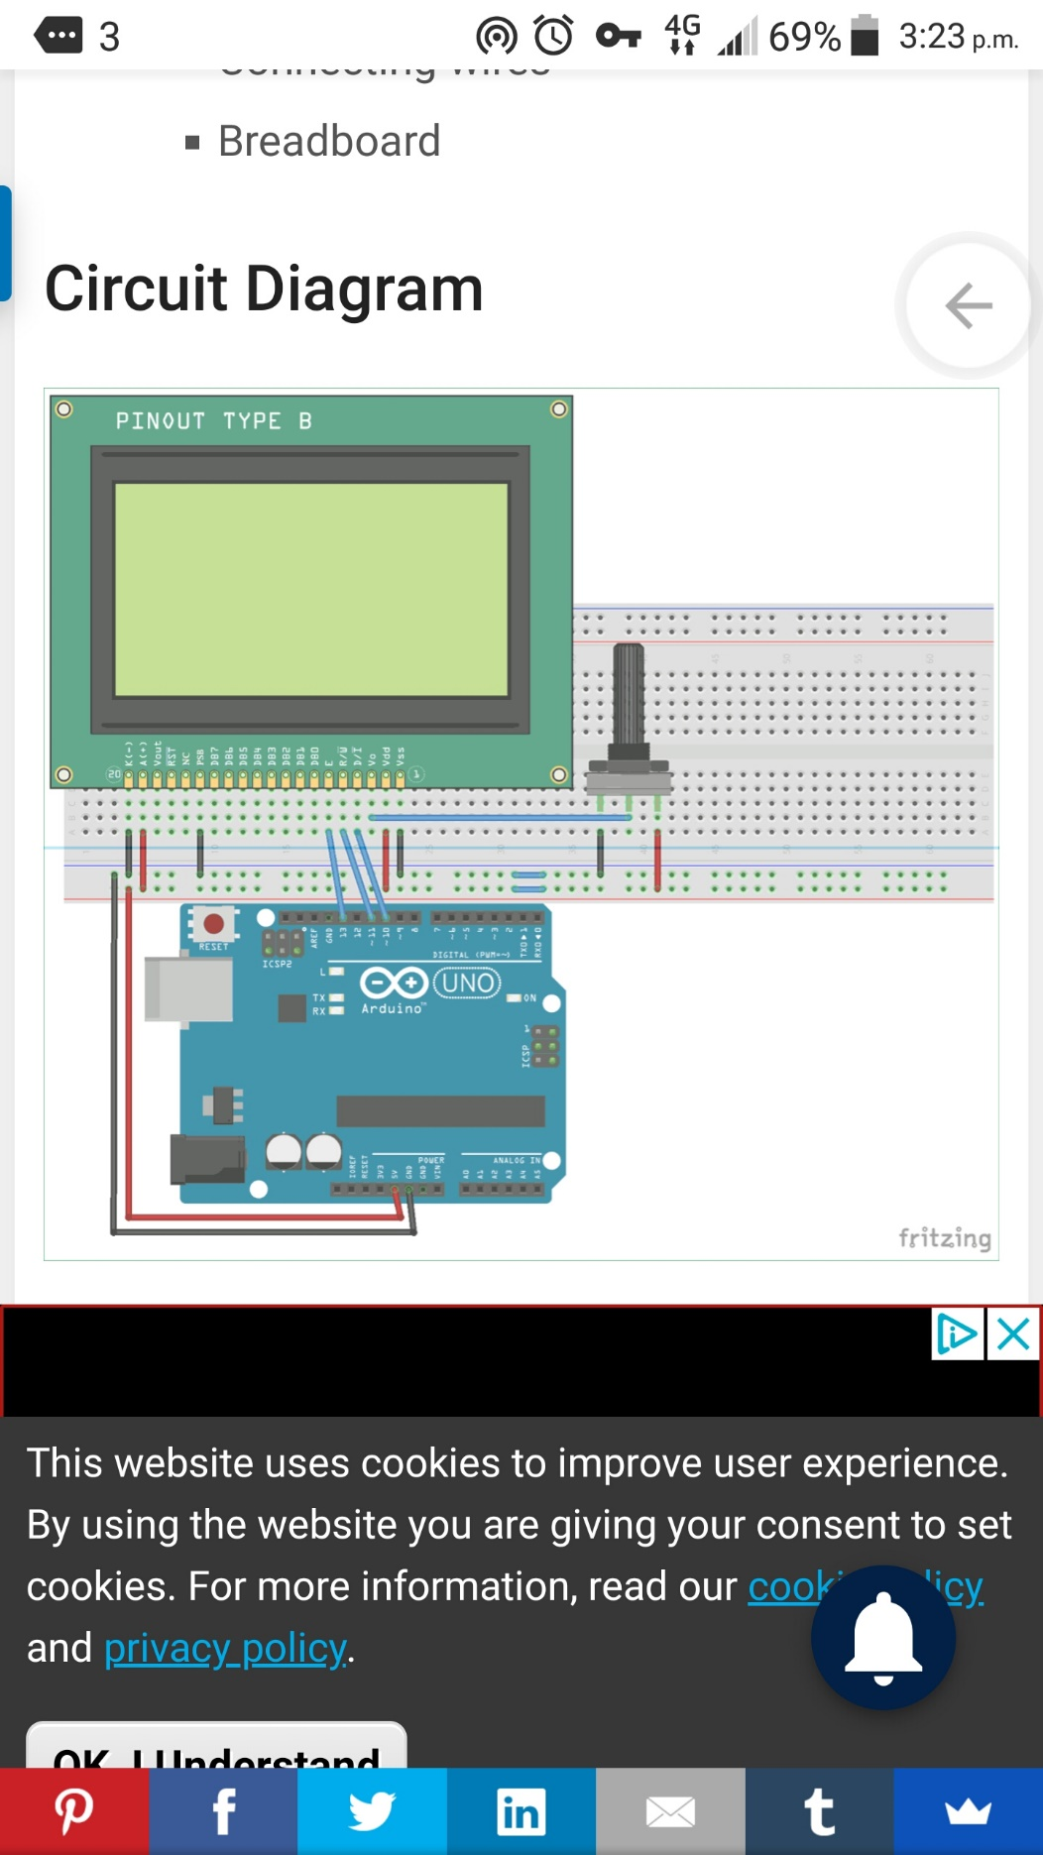

Photo credit: Circuit DIgest

**PROCEDURE**

1. Plug the arduino board to the PC and upload the code from the ‘contactless temperature’ folder.
2. Unplug the arduino board from the PC.
3. Place the temperature and proximity sensors to trace and cut a hole at lower top side of the plastic box where the ir proximity sensor and temperature sensor are to be placed.
4. Assemble the components as in the circuit diagram above.
5. Solder the wires to the glcd display and glue all other connection points.
6. Connect pins 2 and 3 of the arduino board to the Output pin of the ir proximity sensor and positive pin of the buzzer respectively.
7. Connect the VCC and GND of the ir proximity sensor to the power pins of the arduino.
8. Power on to test and adjust the potentiometer to set the display contrast.
9. Arrange the components inside the plastic box as in the image below, using glue to hold them in place.

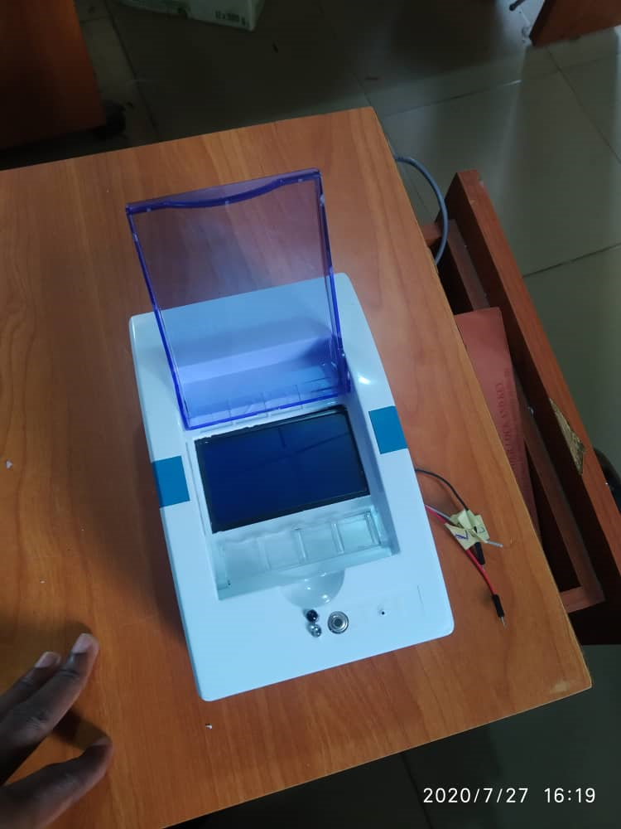

1. Connect the power pins (input) of the arduino to the output of the buck converter while putting the push button in between.
2. Cut a hole on a suitable place on the aluminum composite board to place the power button for the temperature sensor.
3. Attach the box to the frame using screws.
4. Power on and test.